**Venkataramanan** **K**

**DVI_GROUP002**

**DVI_ASSIGNMENT1PS2_BANKING DATA ANALYSIS**

**Ponvani**

**po**

**Balakavin Pon**

**Poornima J**

**Synopsis:**

DATA VISUALIZATION AND INTERPRETATION

Assignment 1 on Bank Data Analysis

Submission on 13 Dec 2019

Assignment #1 | **Data Visualization**

**Bank Data Analysis**

**Venkataramanan K | 2018AC04529**

**Ponvani | 2018AC04559**

**Balakavin Pon | 2018AC04531**

**Poornima J | 2018AC04550**

Analysed and created in collaboration of

Bits, pilani work integrated learning program



# Table of content

Table of content 3

Visualization Context 4

Business Problem 4

Who 4

What 4

How 4

Summary 4

Exploratory Data Analysis: 5

Age distribution: 5

Loan: 6

Chart 1: Age vs Campaign 11

Questions: 11

Analysis: 11

Inference: 11

Chart 2: effectiveness of campaign compared with social and economic measures 12

Questions: 12

Analysis: 13

Inference: 13

ChART 3: Campaigns against job and education 14

Dashboard 15

# Visualization Context

## Business Problem

The bank wants to run the marketing campaign on the huge diversified product portfolio. Generally, the marketing department runs several marketing campaign times to time, the details about those campaigns are documented properly. We need to analyze the data collected during the marketing campaign and provide a recommendation or suggestions on the contributing factors for the successful purchase of the product. This enables the marketing team to focus on the significant factors to make the campaign more successful on selling the product to customers.

## Who

Management and Board members of the bank. They are the target audience for the analysis and outcome of the marketing department campaign on their financial products.

## What

The primary objective of this analysis is to understand and get an insight about the previously conducted market campaign on the bank products to various types of customers. The outcome of the analysis will contain the suggestions and recommendation to give a direction to leaders of the organization and the marketing department about both the success factors and needs to improvement factors. This will give them an insight on where they need to improve their marketing strategy to make it more effective.

## How

During the marketing campaign the department gathered the data as a log of process and outcomes. At the end of the campaign these data will be used for analysis to identify the contributing factors for the success of the campaign and area of focus to improve the campaign more effectively.

## Summary

**Who:** Bank Senior Management Executives for funding and approving such marketing campaign in future.

**What:** The marketing campaign was moderately effective and analysis outcome will give clear insights on where to focus on improving the effectiveness

**How:** Demonstrate the results of the campaign with collected data after the market campaign and sales of their financial product.

## Exploratory Data Analysis:

There are around 41188 marketing campaign data are available, out of which 4640 i.e. 11.27% of people had purchased the product.

### Age distribution:

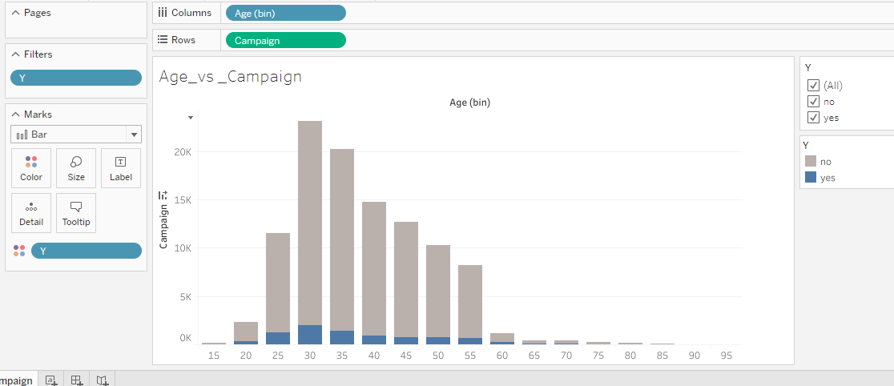

**Inference:** People between the ages 25 to 40 are active customers.

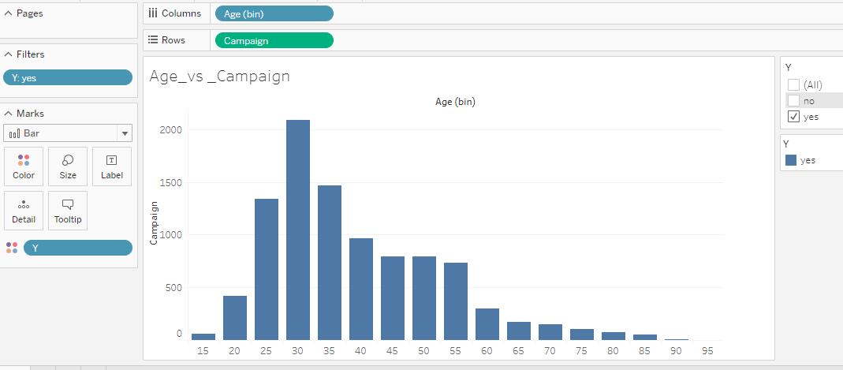

### Loan:

**Defaulter:** 90% of People who are Non defaulter are purchasing. 10% are unknown.

We can target the non-defaulters.

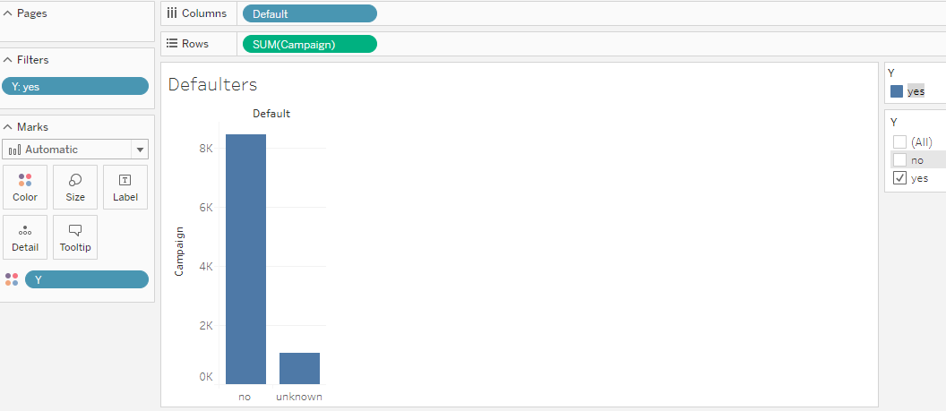

**Mode of Contact:**

83% of people are contacted via cellphone had purchased.

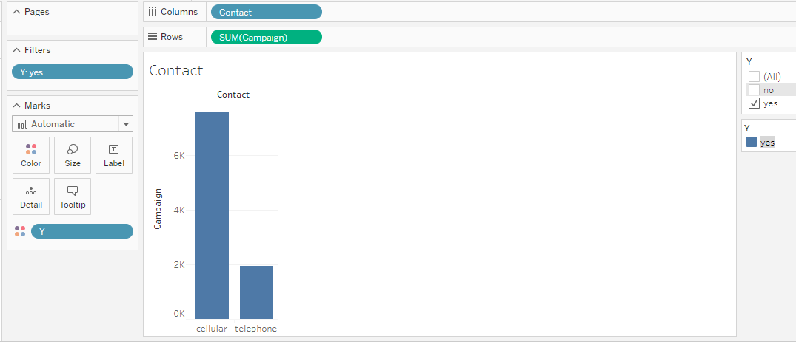

**Loan:** Has personal loan?

82% of people who are not having personal loans are purchasing.

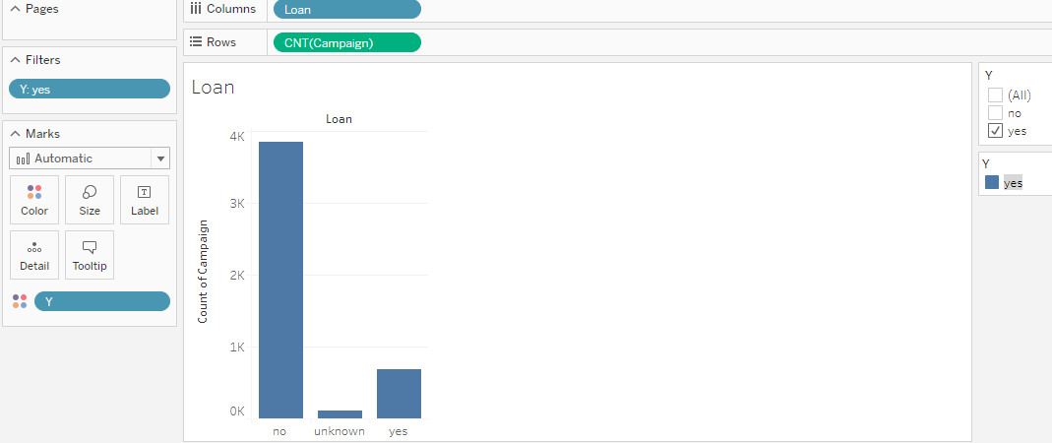

**Housing:** has housing loan?

Not a major difference between the People having/not housing loan.

54.03% of people who are having housing loan had purchased

43.66% of people who did not purchase are not having housing loan.

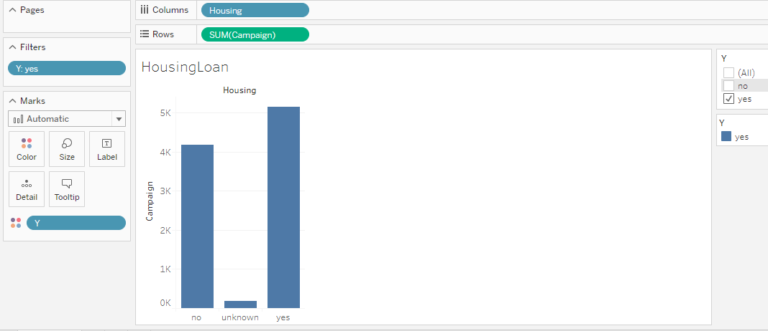

**Month:** It is observed that Dec month is having less than 2% percentage of purchase and no records for Jan and Feb. So, it is better to avoid during year end and jan&feb.

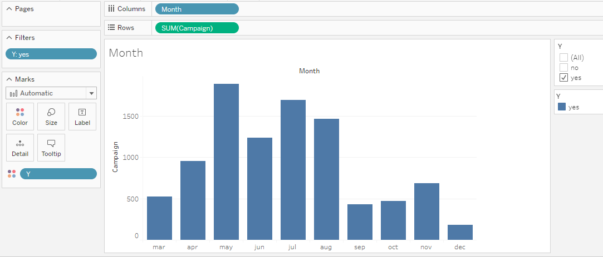

**Marital:** 50% of married people are purchasing.

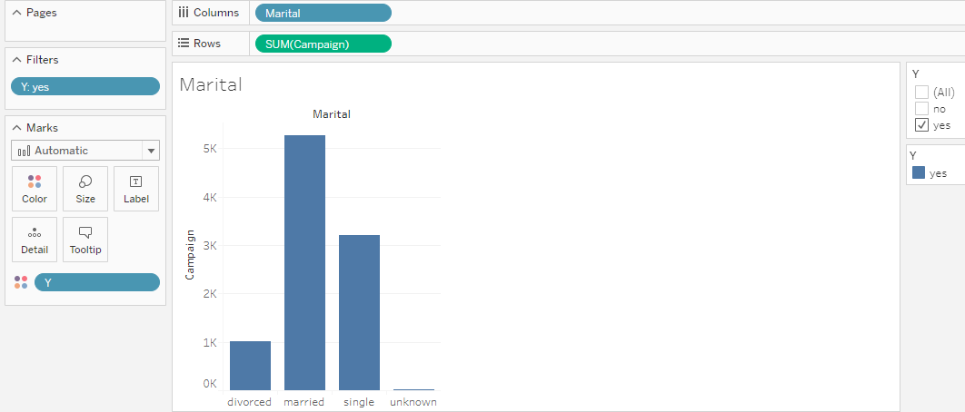

**Pdays:** (number of days that passed by after the client was last contacted from a previous campaign

999 means client was not previously contacted.)

79% -it is evident that people who are **Newly** contacted or contacted within 1st week after campaign are purchasing.

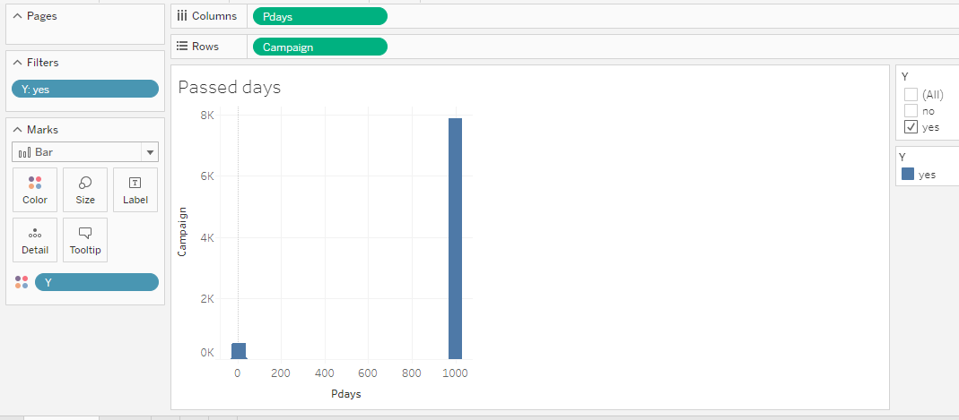

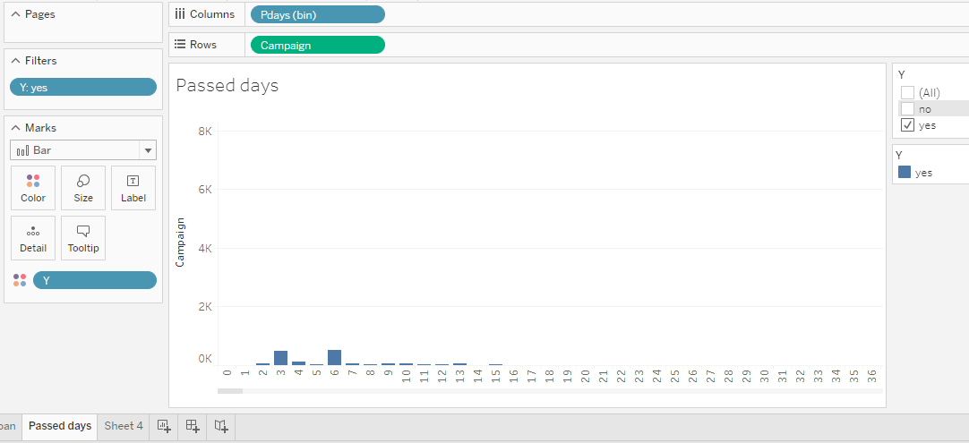

# Chart 1: Age vs Campaign

### Questions:

1. Do we need to change the campaign strategy based on the age group of a customer? Or same campaign can be used for all age group?
2. Which Age group of customers had received the campaign positively and shown a significant result?

### Analysis:

As per our analysis we have noticed that a greater number of people between the age **25 to 45** have purchased the products. We want show this as a visualization by grouping age using Bin to see the count of the age grouped against number of people purchased.

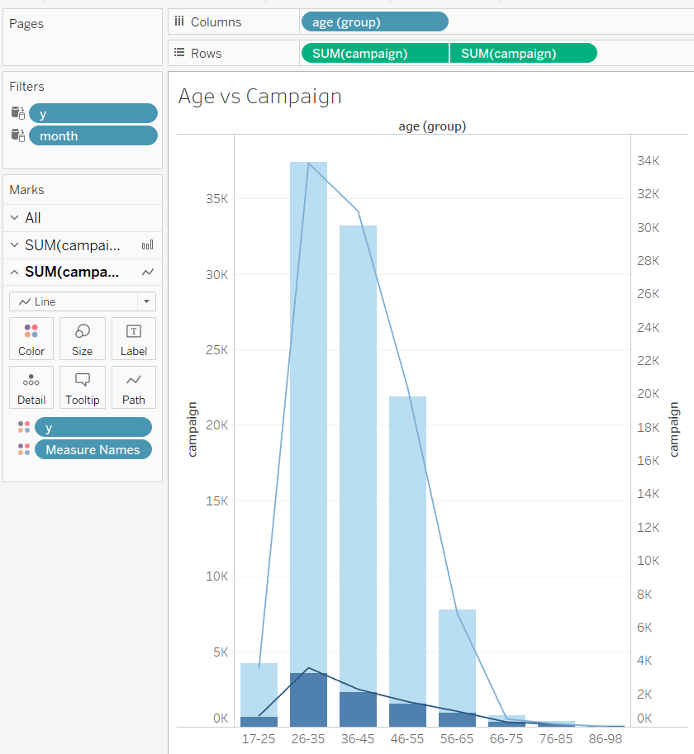So, we used Bar chart which helps to compare number of people (in y axis) and the age grouped (in x axis).

We also showed that, how many people we have contacted for campaign and how many people have successfully purchased using the color option in same bar chart.

This carries lot of information without any clutter.

The analysis gave an indicative perspective on which age group needs to be targeted for the financial product campaign. The age group on both extremes as young population (17-26) and old population from (76-98) did not show any significant effect on the buying the products. Which is very evident that these age group people are not much inclined in investing financially.

### Inference:

The outcome of this analysis shows us that the campaign is highly effective in the age group 26-45 and moderately effective in 46-55. At the same time, the campaign should be made separately to suit the age group of the customer rather than having single campaign for all the age group.

# Chart 2: effectiveness of campaign compared with social and economic measures

### Questions:

**Consumer Price Index(CPI)**

1. On the given consumer price index(CPI), how did the campaign performed among the customer base?
2. Is there any correlation on Consumer Price Index(CPI) and purchase of the product?

**Average Employment Vacancy Rate**

1. How did the campaign perform against the average employment vacancy rate(AEVR) on different months?
2. Was there any significant relation between product purchase on the AEVR?

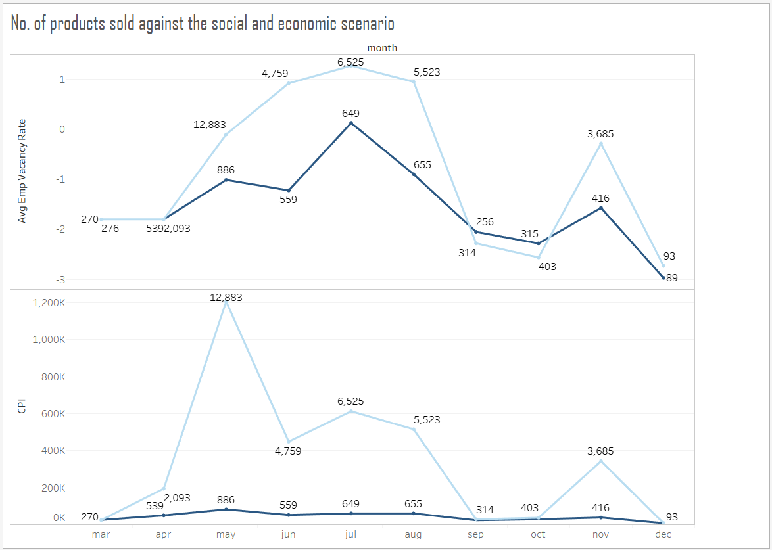

### Analysis:

In the analysis, the variables CPI and Average employment vacancy rate were compared with the campaign conducted across the months of the year. We have found that there is an increase in purchase when there is positive Avg. Emp. Vacancy rate (**> 0.5**). On the other hand, the non-purchase count and purchase counts were almost equal when the AEVR rate is **<=-2**.

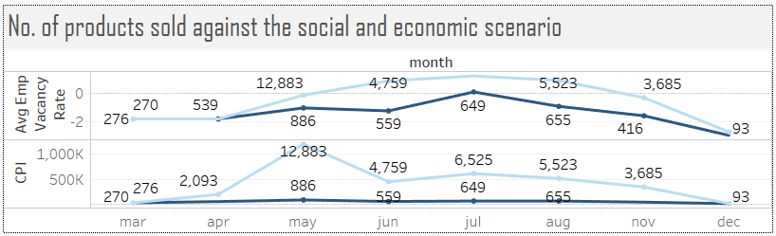

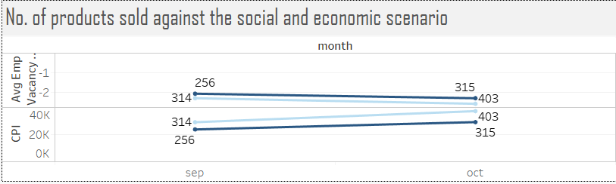With respect to CPI measures, there is no significance change on the product purchase counts, they were almost a straight line across all the months. Whereas, we could see a peek raise on non-purchase counts during the period of Apr to May and steady decline from May to June. During that time there is an increase in the CPI rate as well, which could make the people to not invest in any Banking scheme rather, spending nature of people might be higher.

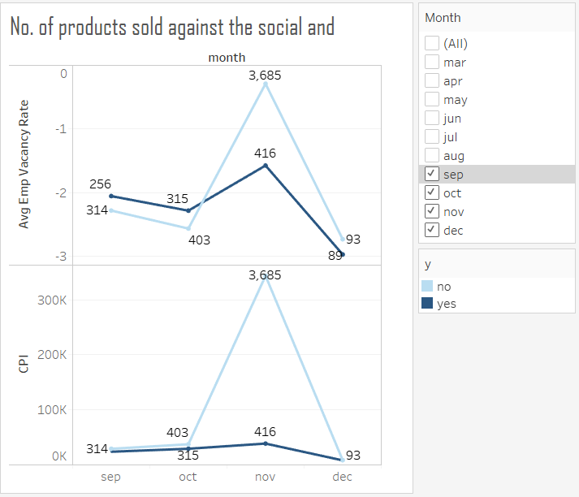In a similar fashion, after the month September there is a decline trend on both purchase and non-purchase count where the AEVR values also going deep belowless than **-2.5.**

If we take a look at the graph of CPI there is a sudden raise of non-buyers count during Oct-Nov month and then there is a steep decrease in count.

### Inference:

The average employment vacancy rate is a contributing factor on the performance of the campaign. We need to be sure the rate of average employment vacancy. When the vacancy is higher the conducting campaign on investing in bank products or scheme is not a wise idea. On the other hand, when the CPI is less than **<100K** then there was a steady margin on buying the product. However, there are no significant increase in purchase is seen when the CPI is increased more than **100K**.

# ChART 3: Campaigns against job and education

We have noticed that people who are illiterate does not buy. Then we drilled down and checked that a greater number of people who have completed University and professional degree have purchased more.

People who are working as Admin have purchased more. So, we wanted to compare the count of people who are interested in buying against each profession. also, we wanted to categorize the people against education as well.

To show all these comparison in a single chart we find bar chart suits well.

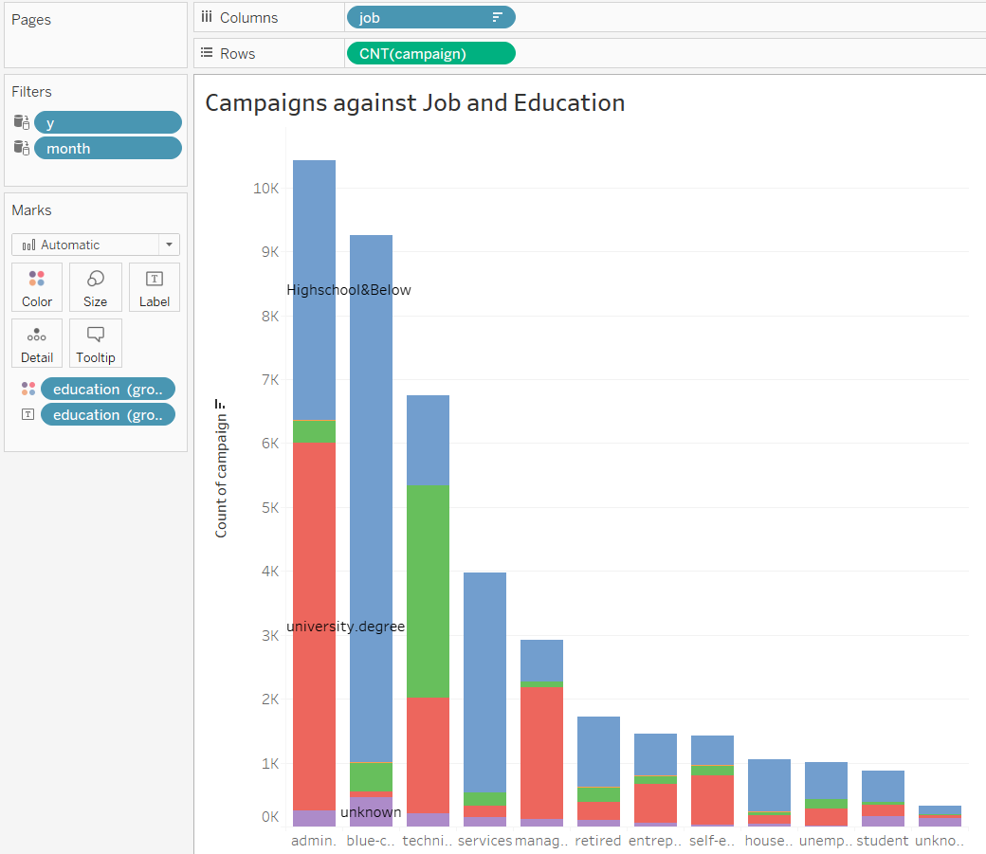

# Dashboard

